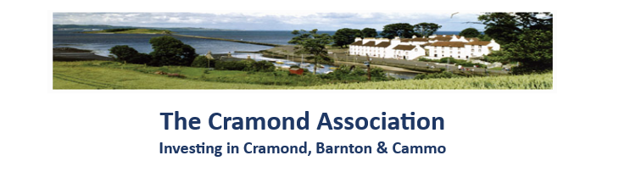

SUBSCRIPTIONS 2024-25

The Annual Subscription for Cramond Association is now due. Subscriptions for the forthcoming year are as shown below. Please complete this form and return it, together with your remittance (if paying by cheque), to Ms Jenny Purcell, Treasurer, at the address shown below.

Single person household £10 £
Household with more than one person £20 £
History Section £8 £
Donation £
Total £ _____

Boost your donation by 25p Gift Aid for every £1 you donate. Gift Aid is reclaimed by Cramond Association from the tax you pay for the current tax year. Your address is needed to identify you as a current UK taxpayer.

I am a UK taxpayer and understand that if I pay less Income Tax and/or Capital Gains Tax than the amount of Gift Gift Aid claimed on all my donations in that tax year, it is my responsibility to pay any difference.

Name ……………………………………………………………………………………………………………. (Please enter the names of
all members of the
Address ………………………………………………………………………………………………………… household age 16 or over)

………………………………………………………………………………………………………………………

Post Code ………………………… Telephone number …………………………………………… ………….…..

Email address (please print very clearly!) ……………………………………………………………………………………………... ………………
Under the General Data Protection Regulation 2018, by giving us your email address you are deemed to agree to the following: "I consent to Cramond Association holding my name and email address and using this information for the purposes of contacting me from time to time about the Association. This information will be used only for Association matters and will not be passed to any external individual or agency.
METHODS OF PAYMENT (Please choose the method most convenient for you and tick the appropriate box.)
1) Please pay by electronic transfer into Cramond Association RBS Account:
Account Name: The Cramond Association
Sort Code: 83-18-47
Account No: 10895548
Please use your address as the reference.

2) Cheques should be made payable to ‘The Cramond Association’ and sent to:
Ms J Purcell
4a Cramond Crescent
Edinburgh
EH4 6PG

